**DAILY ONLINE ACTIVITIES SUMMARY**

|  |  |  |  |  |  |  |  |  |
| --- | --- | --- | --- | --- | --- | --- | --- | --- |
| **Date:** | **19/06/2020** | | | | | **Name:** | **Pratibha Shetti** | |
| **Sem & Sec** | **IV sem & B section** | | | | | **USN:** | **4AL18CS062** | |
| **Online Test Summary** | | | | | | | | |
| **Subject** | | **Microcontroller and Embedded Systems** | | | | | | |
| **Max. Marks** | | **20** | | **Score** | | | **20** | |
| **Certification Course Summary** | | | | | | | | |
| **Course** | **Introduction to information security** | | | | | | | |
| **Certificate Provider** | | | **Greatlearning academy** | | **Duration** | | | **5.5hours** |
| **Coding Challenges** | | | | | | | | |
| **Problem Statement1:** Given a positive integer n, count the total number of set bits in binary representation of all numbers from 1 to n  **Problem Statement2**Matrix Rotation by 90 Degree in Clockwise Direction | | | | | | | | |
| **Status: Executed** | | | | | | | | |
| **Uploaded the report in Github** | | | | | **YES** | | | |
| **If yes Repository name** | | | | | <https://github.com/pratibhashetty-123/Lockdown-coding-java>  <https://github.com/pratibhashetty-123/Lockdown-coding-for-C> | | | |
| **Uploaded the report in slack** | | | | | **YES** | | | |

Online Test Summary: 18CS44 test was scheduled from 3:00 pm t0 3:30pm .The portion for the IA was 4th module there were 20 questions and the time assigned was 30 minutes the questions were mcq type.

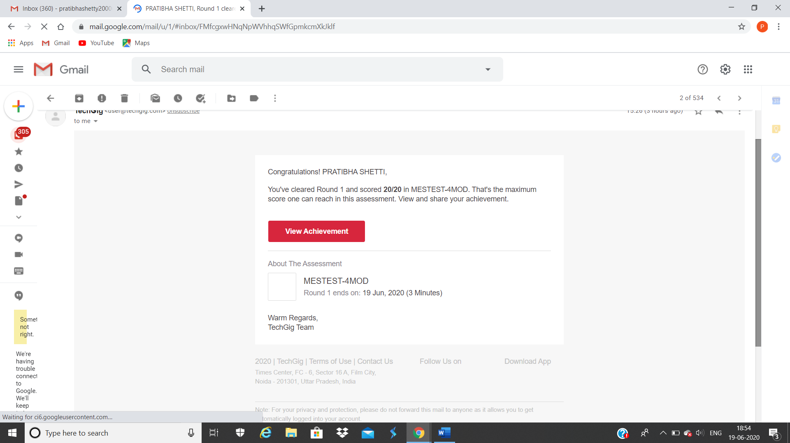

The above snap shot is the completion of the test and the marks allotted. 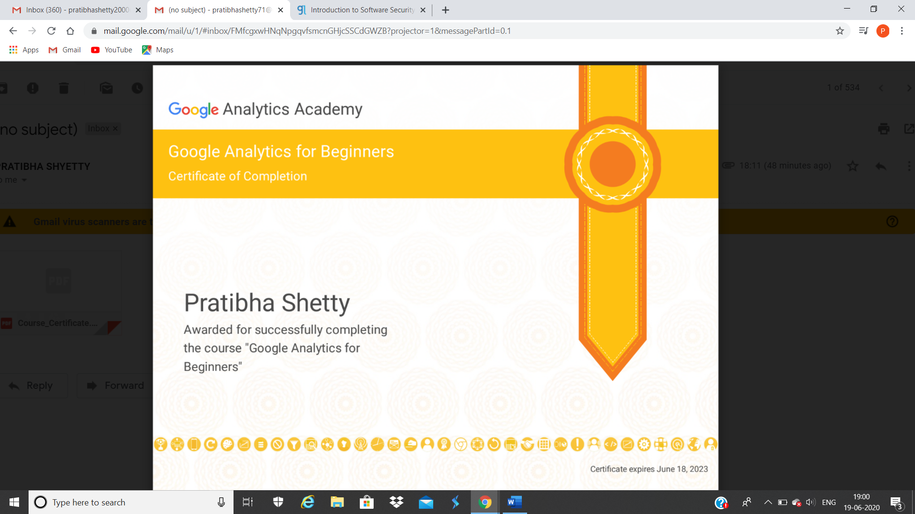

Certificate for completion of google analytic for beginers

Online Course Summary: In today’s session I have learnt about security goals and implementation

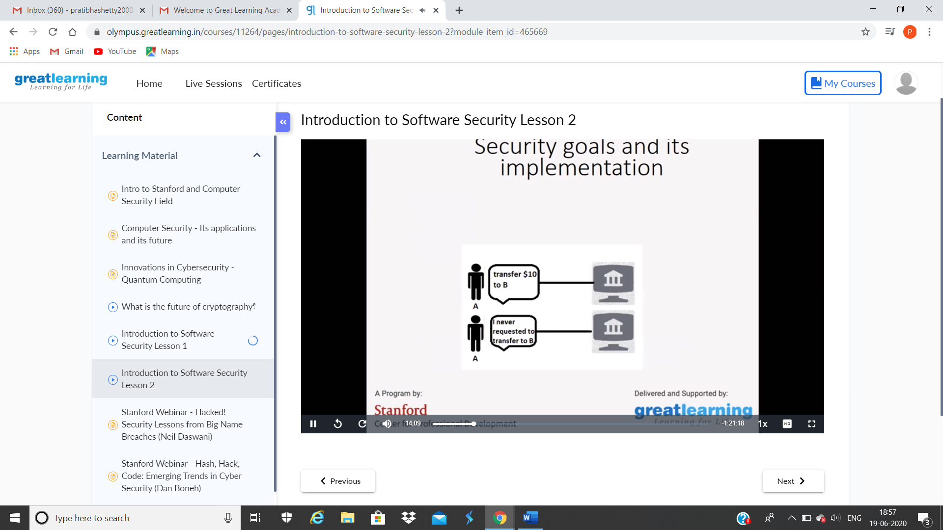

These are the snapshots of today’s session.

Online Coding Summary: **Today I had received one program from prof.**

**Shilpa CSE Dept. and from Prof. Venkatesh CSE Dept. The program is**

**mentioned above in the coding challenges(pg.01). I have also uploaded**

**it to my Github repository.**

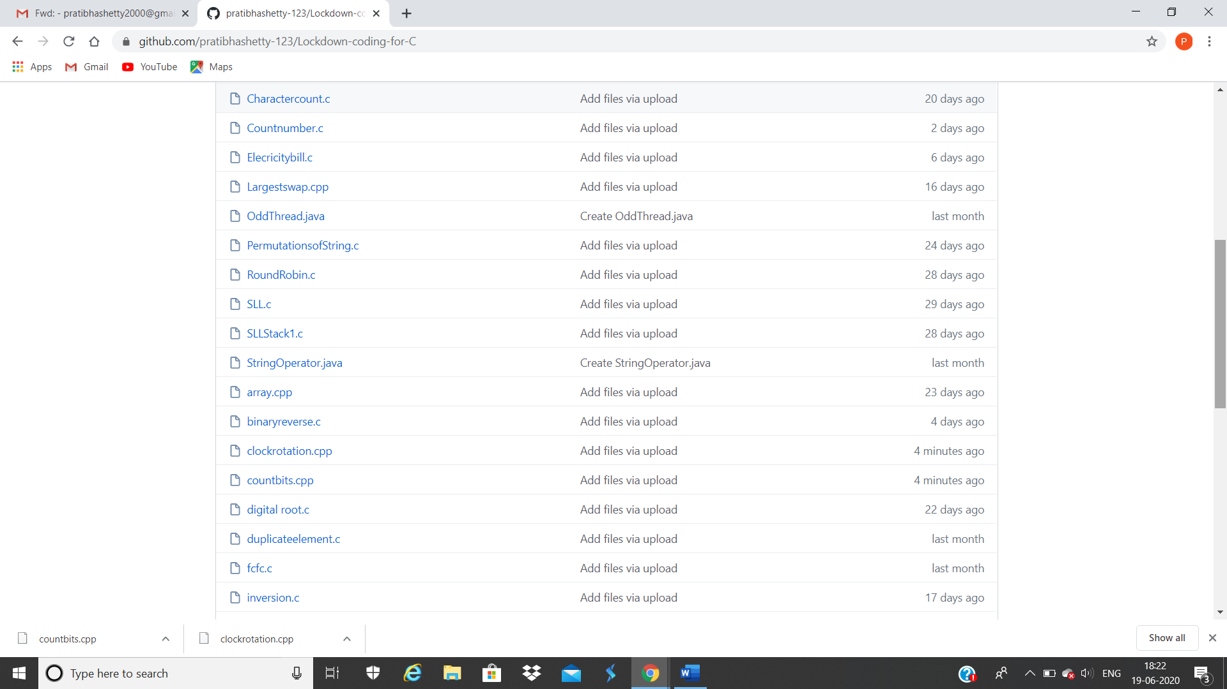

It is the snap shot of my repository were I have uploaded the code. File name is clockrotation.cpp and countbits.cpp